## Creating table for the data

create table coffee_shop_sales

(

transaction_id int,

transaction_date date,

transaction_time time,

transaction_qty int,

store_id int,

store_location varchar(30),

product_id int,

unit_price decimal,

product_category varchar(25),

product_type varchar(50),

product_detail varchar(50)

)

### Importing the csv file

copy coffee_shop_sales

from 'C:\Program Files\PostgreSQL\16\data\data_copy\coffee_shop_sales.csv'

delimiter ','

csv header;

## Finding total sales of the month- here 3 = March

SELECT CAST(ROUND(SUM(unit_price * transaction_qty), 2) AS NUMERIC(10, 2)) AS Total_Sales

FROM coffee_shop_sales

WHERE EXTRACT(MONTH FROM transaction_date) = 3;

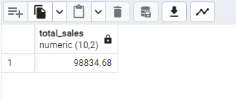

## Finding month-on-month increase or decrease in sales

SELECT

EXTRACT(MONTH FROM transaction_date) AS month_sale,

CAST(ROUND(SUM(unit_price * transaction_qty), 2) AS DECIMAL) AS total_sales,

ROUND(

(

(

SUM(unit_price * transaction_qty) - LAG(SUM(unit_price * transaction_qty), 1)

OVER (ORDER BY EXTRACT(MONTH FROM transaction_date))

) / LAG(SUM(unit_price * transaction_qty), 1) OVER (ORDER BY EXTRACT(MONTH FROM transaction_date))

) * 100,

2

) AS mon_increase_percentage

FROM

coffee_shop_sales

WHERE

EXTRACT(MONTH FROM transaction_date) IN (4, 5)

GROUP BY

EXTRACT(MONTH FROM transaction_date)

ORDER BY

EXTRACT(MONTH FROM transaction_date);

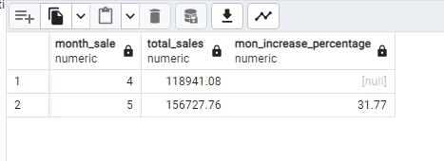

## Finding all months sales, January to June

SELECT

EXTRACT(MONTH FROM transaction_date) AS month_sale,

EXTRACT(YEAR FROM transaction_date) AS year_sale,

SUM(unit_price * transaction_qty) AS total_sales

FROM

coffee_shop_sales

GROUP BY

EXTRACT(YEAR FROM transaction_date),

EXTRACT(MONTH FROM transaction_date)

ORDER BY

EXTRACT(YEAR FROM transaction_date),

EXTRACT(MONTH FROM transaction_date);

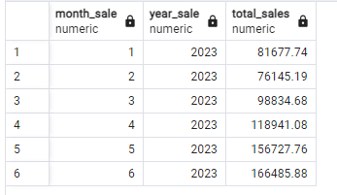

### another code with month name

SELECT

CASE EXTRACT(MONTH FROM transaction_date)

WHEN 1 THEN 'January'

WHEN 2 THEN 'February'

WHEN 3 THEN 'March'

WHEN 4 THEN 'April'

WHEN 5 THEN 'May'

WHEN 6 THEN 'June'

WHEN 7 THEN 'July'

WHEN 8 THEN 'August'

WHEN 9 THEN 'September'

WHEN 10 THEN 'October'

WHEN 11 THEN 'November'

WHEN 12 THEN 'December'

ELSE 'Unknown' -- Handle unexpected cases

END AS month_name,

EXTRACT(YEAR FROM transaction_date) AS year_sale,

SUM(unit_price * transaction_qty) AS total_sales

FROM

coffee_shop_sales

GROUP BY

EXTRACT(YEAR FROM transaction_date), -- Group by year

EXTRACT(MONTH FROM transaction_date) -- Group by month

ORDER BY

EXTRACT(YEAR FROM transaction_date),

EXTRACT(MONTH FROM transaction_date);

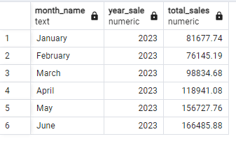

## Finding the difference in sales between the selected month and the previous month.

WITH MonthlySales AS (

SELECT

CASE EXTRACT(MONTH FROM transaction_date)

WHEN 1 THEN 'January'

WHEN 2 THEN 'February'

WHEN 3 THEN 'March'

WHEN 4 THEN 'April'

WHEN 5 THEN 'May'

WHEN 6 THEN 'June'

ELSE 'Unknown'

END AS month_sale,

SUM(unit_price * transaction_qty) AS total_sales,

LAG(SUM(unit_price * transaction_qty))

OVER (ORDER BY EXTRACT(MONTH FROM transaction_date)) AS prev_month_sales

FROM

coffee_shop_sales

WHERE

EXTRACT(YEAR FROM transaction_date) = 2023

GROUP BY

EXTRACT(MONTH FROM transaction_date)

)

SELECT

month_sale,

total_sales,

COALESCE(total_sales - prev_month_sales, 0) AS sales_difference

FROM

MonthlySales

ORDER BY

CASE month_sale

WHEN 'January' THEN 1

WHEN 'February' THEN 2

WHEN 'March' THEN 3

WHEN 'April' THEN 4

WHEN 'May' THEN 5

WHEN 'June' THEN 6

ELSE 7 -- 'Unknown' will appear at the end

END;

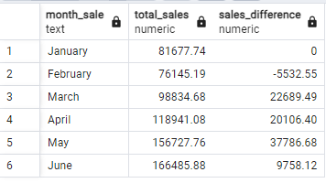

## calculate the total number of orders for each month

select * from coffee_shop_sales

SELECT

count(transaction_id) AS total_qty,

CASE EXTRACT(MONTH FROM transaction_date)

WHEN 1 THEN 'January'

WHEN 2 THEN 'February'

WHEN 3 THEN 'March'

WHEN 4 THEN 'April'

WHEN 5 THEN 'May'

WHEN 6 THEN 'June'

WHEN 7 THEN 'July'

WHEN 8 THEN 'August'

WHEN 9 THEN 'September'

WHEN 10 THEN 'October'

WHEN 11 THEN 'November'

WHEN 12 THEN 'December'

ELSE 'Unknown' -- Handle unexpected cases

END AS month_name

FROM

coffee_shop_sales

GROUP BY

CASE EXTRACT(MONTH FROM transaction_date)

WHEN 1 THEN 'January'

WHEN 2 THEN 'February'

WHEN 3 THEN 'March'

WHEN 4 THEN 'April'

WHEN 5 THEN 'May'

WHEN 6 THEN 'June'

WHEN 7 THEN 'July'

WHEN 8 THEN 'August'

WHEN 9 THEN 'September'

WHEN 10 THEN 'October'

WHEN 11 THEN 'November'

WHEN 12 THEN 'December'

ELSE 'Unknown'

END

ORDER BY

MIN(EXTRACT(MONTH FROM transaction_date)); -- Optional: Order by the numerical month order

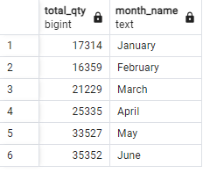

## Determine the month-on-month increase or decrease in the number of orders

SELECT

EXTRACT(MONTH FROM transaction_date) AS MONTH,

CAST(ROUND(COUNT(transaction_id)) AS INTEGER) AS total_orders,

ROUND(

(

(COUNT(transaction_id) - LAG(COUNT(transaction_id), 1)

OVER (ORDER BY EXTRACT(MONTH FROM transaction_date)))::NUMERIC /

LAG(COUNT(transaction_id), 1) OVER (ORDER BY EXTRACT(MONTH FROM transaction_date))

) * 100,

2

) AS month_increase_percentage

FROM

coffee_shop_sales

WHERE

EXTRACT(MONTH FROM transaction_date) IN (2, 3)

GROUP BY

EXTRACT(MONTH FROM transaction_date)

ORDER BY

EXTRACT(MONTH FROM transaction_date);

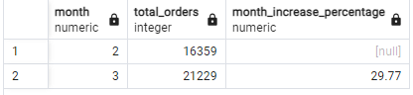

## Calculate the total quantity sold for every month

SELECT

SUM(transaction_qty) AS total_quantity,

CASE EXTRACT(MONTH FROM transaction_date)

WHEN 1 THEN 'January'

WHEN 2 THEN 'February'

WHEN 3 THEN 'March'

WHEN 4 THEN 'April'

WHEN 5 THEN 'May'

WHEN 6 THEN 'June'

WHEN 7 THEN 'July'

WHEN 8 THEN 'August'

WHEN 9 THEN 'September'

WHEN 10 THEN 'October'

WHEN 11 THEN 'November'

WHEN 12 THEN 'December'

ELSE 'Unknown'

END AS month_name

FROM

coffee_shop_sales

WHERE

EXTRACT(YEAR FROM transaction_date) = 2023

GROUP BY

EXTRACT(MONTH FROM transaction_date)

ORDER BY

EXTRACT(MONTH FROM transaction_date);

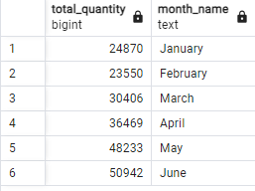

## Total quantity sold on month difference and month growth

SELECT

month_name,

total_quantity,

ROUND(

(total_quantity - LAG(total_quantity, 1) OVER (ORDER BY month_num))::numeric

/ NULLIF(LAG(total_quantity, 1) OVER (ORDER BY month_num), 0) * 100

, 2) AS sales_diff

FROM (

SELECT

EXTRACT(MONTH FROM transaction_date) AS month_num,

CASE EXTRACT(MONTH FROM transaction_date)

WHEN 1 THEN 'January'

WHEN 2 THEN 'February'

WHEN 3 THEN 'March'

WHEN 4 THEN 'April'

WHEN 5 THEN 'May'

WHEN 6 THEN 'June'

WHEN 7 THEN 'July'

WHEN 8 THEN 'August'

WHEN 9 THEN 'September'

WHEN 10 THEN 'October'

WHEN 11 THEN 'November'

WHEN 12 THEN 'December'

ELSE 'Unknown'

END AS month_name,

SUM(transaction_qty) AS total_quantity

FROM

coffee_shop_sales

GROUP BY

EXTRACT(MONTH FROM transaction_date)

) AS monthly_totals

ORDER BY

month_num;

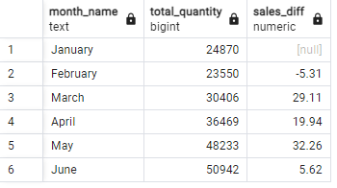

## Calculate total sum, total quantity sold and total orders for particular date

select

round(sum(unit_price * transaction_qty)) as total_sales,

sum (transaction_qty) as tota_qty_sold,

count ( transaction_id) as total_orders

from coffee_shop_sales

where transaction_date = '2023-05-18'

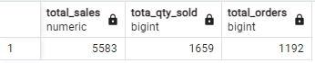

SELECT

CONCAT(

ROUND(SUM(unit_price * transaction_qty) / 1000.0, 1),

'k'

) AS total_sales_display,

CONCAT(

ROUND(SUM(transaction_qty) / 1000.0, 1),

'k'

) AS total_qty_sold,

CONCAT(

ROUND(COUNT(transaction_id) / 1000.0, 1),

'k'

) AS total_orders

FROM

coffee_shop_sales

WHERE

transaction_date = '2023-05-18';

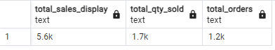

## find sales on weekend

SELECT

CASE

WHEN EXTRACT(DOW FROM transaction_Date) IN (0, 6) THEN 'WEEKENDS'

ELSE 'Weekdays'

END AS day_sales,

concat(round(SUM(transaction_qty * unit_price)/1000,1), 'k') AS total_sales

FROM

coffee_shop_sales

where extract(month from transaction_date) = 2

GROUP BY

CASE

WHEN EXTRACT(DOW FROM transaction_Date) IN (0, 6) THEN 'WEEKENDS'

ELSE 'Weekdays'

END;

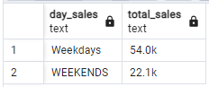

## SALES VALUE BY STORE LOCATION

SELECT store_location, concat(round(sum(unit_price*transaction_qty)/1000,2), 'K') as total_sales

from coffee_shop_sales

where extract(month from transaction_date)=5

group by store_location

order by sum(unit_price*transaction_qty) desc;

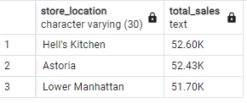

## Daily sale for particular month

SELECT

EXTRACT(DAY FROM transaction_Date) AS day_of_month,

SUM(unit_price * transaction_qty) AS total_sales

FROM

coffee_shop_sales

WHERE

EXTRACT(MONTH FROM transaction_date) = 5 -- Filter for May

GROUP BY

EXTRACT(DAY FROM transaction_Date) -- Group by day of the month

ORDER BY

EXTRACT(DAY FROM transaction_Date); -- Optional: Order by day of the month

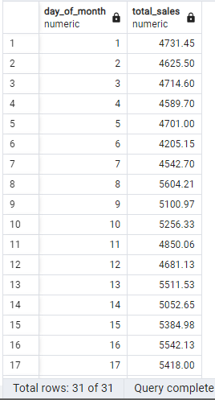

## Calculating total_sales and avg sales for everyday and finding avg line

SELECT

day_of_month,

CASE

WHEN total_sales > avg_sales THEN 'above average'

WHEN total_sales < avg_sales THEN 'below average'

ELSE 'average'

END AS sales_status,

total_sales

FROM (

SELECT

extract(day from transaction_date) AS day_of_month,

SUM(unit_price * transaction_qty) AS total_sales,

avg(SUM(unit_price * transaction_qty)) OVER () AS avg_sales

FROM

coffee_shop_sales

WHERE

extract(month from transaction_date) = 5

GROUP BY

extract(day from transaction_date)

) AS sales_summary

ORDER BY

day_of_month;

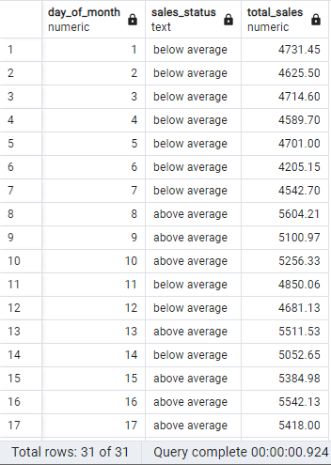

## Calculate sales by product category

select product_category,

sum(transaction_qty* unit_price) as total_Sales

from coffee_shop_sales

where extract(month from transaction_date)=5

group by product_Category

order by 2;

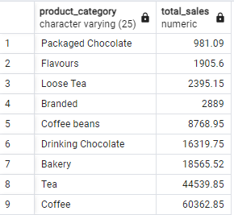

## Finding top 10 product by sales

select product_type,

sum(transaction_qty* unit_price) as total_Sales

from coffee_shop_sales

where extract(month from transaction_date)=5

group by product_type

order by 2 desc

limit 10;

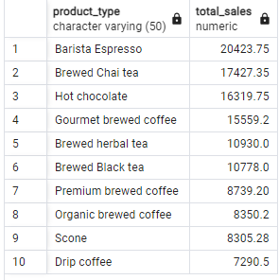

## Finding total sales, total quantity sold in particular time of the day in particular month

SELECT

SUM(transaction_qty * unit_price) AS total_sales,

SUM(transaction_qty) AS total_quantity_sold,

COUNT(*)

FROM

coffee_shop_sales

WHERE

EXTRACT(MONTH FROM transaction_date) = 5

AND EXTRACT(DOW FROM transaction_date) = 1

AND EXTRACT(HOUR FROM transaction_time) = 8

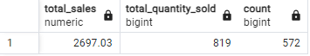

## Find total sales in the hour of the day in month

select extract(hour from transaction_time),

sum(unit_price*transaction_qty) as total_sales

from coffee_shop_sales

where extract(month from transaction_date)=5

group by extract(hour from transaction_time)

order by extract(hour from transaction_time)

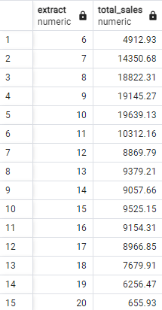

## Calculate total sale for per day of the month

select

case

when extract(dow from transaction_date)=1 then 'Monday'

when extract(dow from transaction_date)=2 then 'Tuesday'

when extract(dow from transaction_date)=3 then 'Wednesday'

when extract(dow from transaction_date)=4 then 'Thursday'

when extract(dow from transaction_date)=5 then 'Friday'

when extract(dow from transaction_date)=6 then 'Saturday'

else 'sunday'

end as days_of_the_week,

round(sum(unit_price*transaction_qty)) as total_sales

from

coffee_shop_sales

where extract(month from transaction_date)=5

group by

case

when extract(dow from transaction_date)=1 then 'Monday'

when extract(dow from transaction_date)=2 then 'Tuesday'

when extract(dow from transaction_date)=3 then 'Wednesday'

when extract(dow from transaction_date)=4 then 'Thursday'

when extract(dow from transaction_date)=5 then 'Friday'

when extract(dow from transaction_date)=6 then 'Saturday'

else 'sunday'

end;

